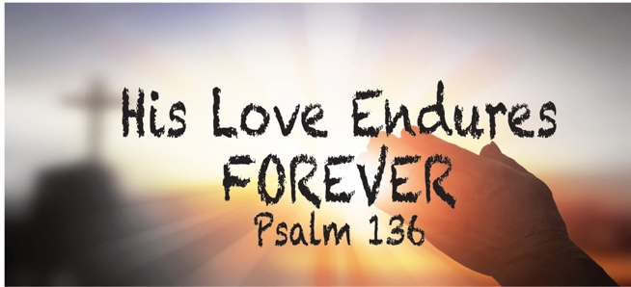
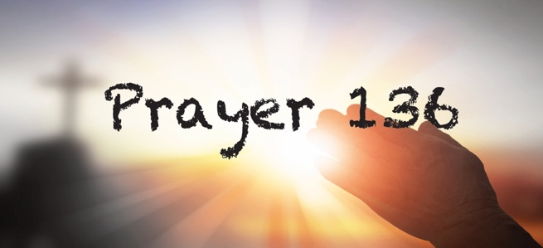

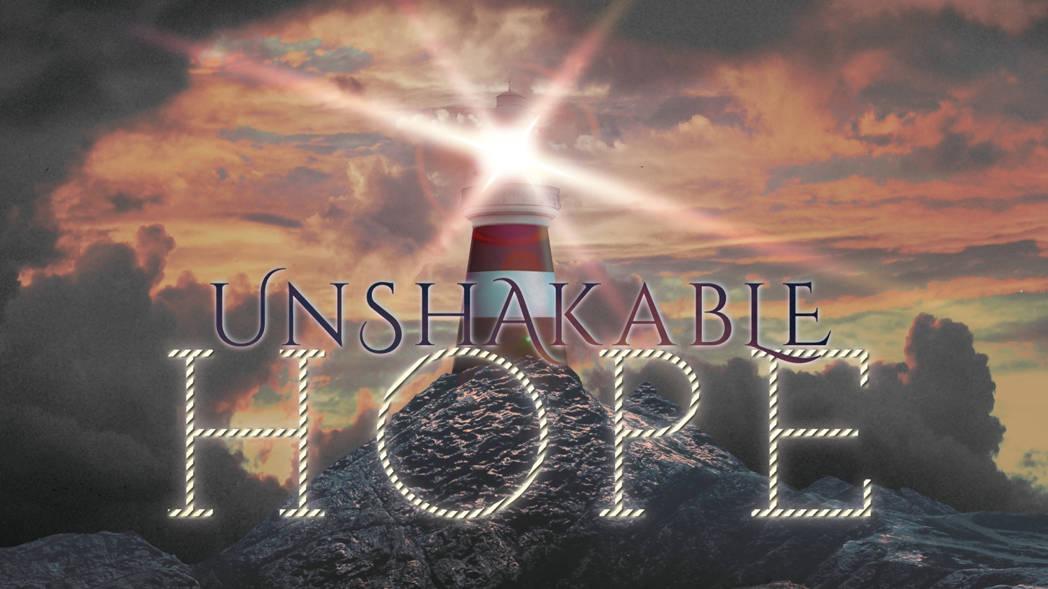

We are building our lives on the promises of God. Because his Word is unbreakable, our hope is unshakable. We do not stand on the problems of life or the pain in life. We stand on the great and precious promises of God.
Wivey Evangelical
Newsletter
September 2022

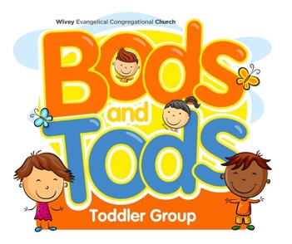
Dates for your Diary:

Bods and Tods restarts Tuesday 20th September

10am to 12pm.

Coffee Pot each Wednesday Morning at 10.30am.

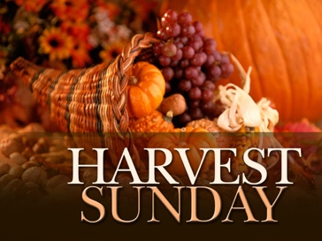
No Connect lunch in September BUT

Harvest Service at 11am on Sunday 25th September followed by Soup, Roll and Pudding lunch.

Sat morning 24th September decorating Chapel for Harvest. 10 am start.
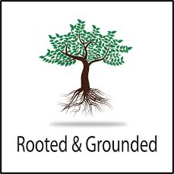
Rooted and Grounded Bible Studies restart:

Thursday Morning 22nd September 10.30am for 10.45 start.

Followed by Prayer 136 prayer meeting (12 am till 1pm approx.) Join us as we pray together.

Friday Afternoon 23rd September 2.45pm for a 3pm start.

We also plan to do a bible basic /introduction course. Dates and times to be confirmed. Please let Martyn know if you are interested.

The upper hall (band room) has now been redecorated and we are waiting for the Carpet to be fitted. We plan to hold a morning service in the Upper Room, re dedicating the room and giving thanks for God’s provision etc Date to be confirmed.

Our next Café Church will be on 30th October

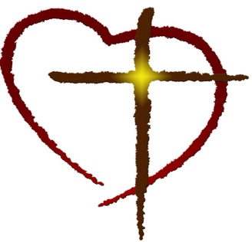
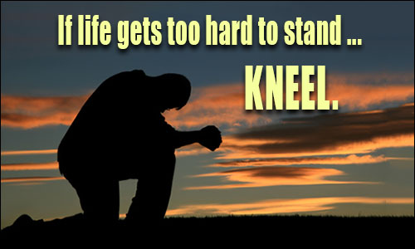

Greetings: We hope that this newsletter finds you well. In September we often start a new season a new term...or so it seems.
After the relaxing and hopefully uplifting holiday, we start this Autumn Season with a prayerful sense of expectation and hope. It is a chance to regroup, re focus our efforts, to re affirm our vision and intentions for the months ahead. The days may be getting shorter, the leaves may be changing colour, but we will be sharing a warm ‘fireplace’ of welcome and encouragement.
However, there are needs and challenging issues that many in our community are facing. The cost of living, interest rates, rising fuel costs that are affecting so many. And we need to be supportive (if we can) of those in need.
Our values are being challenged at every stage: abortion, end of life care, issues on sexuality. A change of standards and morals that are disturbing, both to folk of faith and of no faith at all. There are wars and rumours of wars on every continent
We could go on. And that is just what the enemy wants. For us to be so downtrodden, browbeaten, and intimidated. Negativity, pessimism, oppressed.
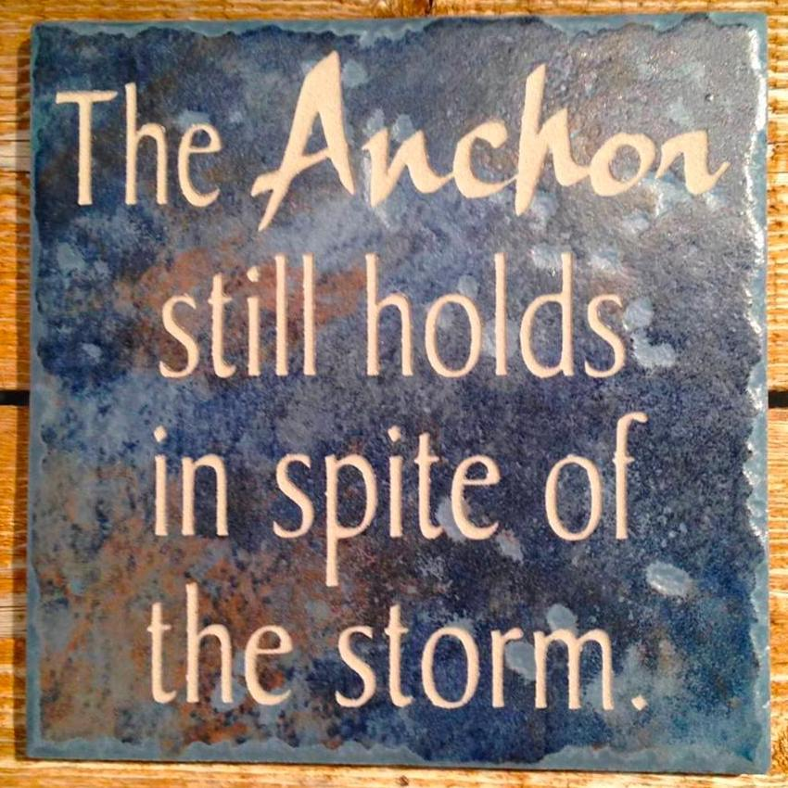
As people of faith, we have a different agenda, a different message. One of hope and encouragement. In life, there are many challenges. It’s a season of life. There is a time for mourning or celebrating, a time to fight or rejoice, a time to question or trust, but there is one thing we always hold onto, Hope.

Most people understand hope as wishful thinking, as in "I hope something will happen." This is not what the Bible means by hope. The biblical definition of hope is "confident expectation."

Living hope is anchored in the past—Jesus rose from the dead (Matthew 28:6). It continues in the present—Jesus is alive (Colossians 3:1). And it endures throughout the future—Jesus promises eternal, resurrection life (John 3:16; 4:14; 5:24; Romans 6:22; 1 Corinthians 15:23).

Living hope also enables us to live without despair as we encounter suffering and trials in this present life: “Therefore we do not give up. Even though our outer person is being destroyed, our inner person is being renewed day by day. For our momentary light affliction is producing for us an absolutely incomparable eternal weight of glory. So, we do not focus on what is seen, but on what is unseen. For what is seen is temporary, but what is unseen is eternal” (2 Corinthians 4:16–18, CSB).

The object of our living hope is described in 1 Peter 1:4 as “an inheritance that is imperishable, undefiled, and unfading, kept in heaven for you” . We have an inheritance that will never be touched by death, stained by evil, or faded with time; it is death-proof, sin-proof, and age-proof.
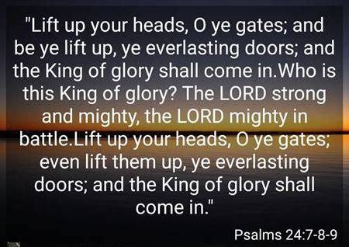
This inheritance is also fail-proof because God guards and preserves it in heaven for us. It is wholly secure. Absolutely nothing can undermine the certainty of our future inheritance.

So instead of being downtrodden and swayed by the latest negative news headline, lift up your heads and see Psalm 24:7-9.

Loving Lord, Help us to be people of Hope...
This season reminds us to wait. To slow down and to wait in expectation for your good and perfect timing. Father, help us to wait.

We do not want to rush into something that isn’t part of your plan. We don’t want to force open a door that you have closed, rather we desire to wait for your perfect will to unfold in our lives. This season reminds us that the wait will be worth it, and that the harvest will come.

We lift our hearts in gratitude to you for guiding our steps, giving us wisdom, and helping us be disciplined and obedient to your ways.

Thank you for your promises and the hope we have in your return.

No matter what we face here, we know that you have prepared a place for us, Jesus. Help us to be patient now and patient for your return. We praise you, oh God, for your goodness and love.
Amen.

Be people of faith, not fear.
Bank Account Details:

Wiveliscombe Evangelical
Congregational Church

Sort Code: 09 01 53

Acc no: 55933284

(We are grateful for your continued support)

Blessings:

Martyn and Felicity.

The Manse: Silver Street.
Wiveliscombe. TA4 2PA

01984 623991 / 07980 591098

Thank you. Just a word of thanks on behalf of Felicity and myself for all the help, assistance, and encouragement that you give us personally and in supporting the fellowship. We are grateful for all that you do. Mp

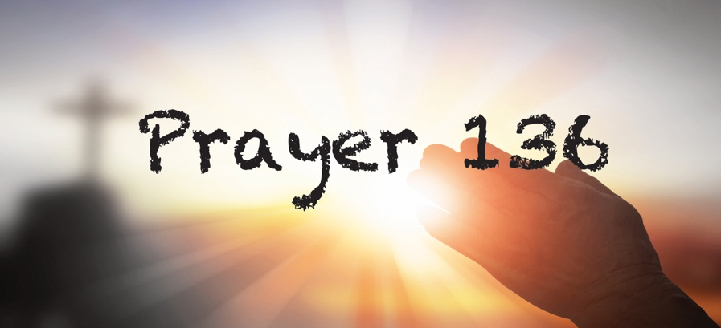

This Month’s (Sept) Prayer Area:

Silver St. , Golden Hill , Wyndhams , Newgate Lane,
The Mews Hauling Way , Coopers Heights , Burges Close ,
Burges lane , Luxton Way , Dixon Close ,
and Huish Champflower .

I waited patiently for the Lord to help me, and he turned to me and heard my cry. He lifted me out of the pit of despair, out of the mud and the mire. He set my feet on solid ground and steadied me as I walked along. He has given me a new song to sing, a hymn of praise to our God. Many will see what he has done and be amazed. They will put their trust in the Lord. Psalm 40:1-3

As we join and meet as a ‘called out people’ this month please pray for our church, town, community. Pray for the Assistant Pastoral application, for the leadership team and all who help and serve our fellowship. That as a team we will be guided and directed by the Lord as we seek to do his vision for our fellowship, will and purpose

We recall all those who are in need, financially, practically, physically, or emotionally. We believe that you are the God who provides, heals, and restores.

We pray for a return “home” to those folk who have chosen a different pathway. The door is always open, and welcome awaits.

This September: We pray that this month is special for you. We pray that September will be a month where you experience God's goodness like never before in your life. We pray today that you see God move and manifest in your life, that you see Him answer your prayers that are in alignment with His Word and His will.
We pray that you experience His healing power where He heals you mentally, physically, spiritually, and financially. That today you rise up from whatever has held you pressed down in life and move forward with God, that you not be ashamed of what you have been through but instead use it as a testimony to help others.

We pray for you, your family, and friends. We pray that all of your needs are met and pray that you have more than enough to be a blessing to someone else in need.

... Amen.

On the lighter side...
A woman brought a very limp duck into a veterinary surgeon. As she laid her pet on the table, the vet pulled out his stethoscope and listened to the bird's chest.
After a moment or two, the vet shook his head and sadly said, "I'm sorry, your duck, Cuddles, has passed away."

The distressed woman wailed, "Are you sure?"
"Yes, I am sure. Your duck is dead," replied the vet.
"How can you be so sure?" she protested. "I mean you haven't done any testing on him or anything. He might just be in a coma or something."
The vet rolled his eyes, turned around and left the room.

He returned a few minutes later with a black Labrador Retriever. As the duck's owner looked on in amazement, the dog stood on his hind legs, put his front paws on the examination table and sniffed the duck from top to bottom. He then looked up at the vet with sad eyes and shook his head.
The vet patted the dog on the head and took it out of the room. A few minutes later he returned with a cat. The cat jumped on the table and also delicately sniffed the bird from head to foot. The cat sat back on its haunches, shook its head, meowed softly and strolled out of the room.

The vet looked at the woman and said, "I'm sorry, but as I said, this is most definitely, 100% certifiably, a dead duck."
The vet turned to his computer terminal, hit a few keys and produced a bill, which he handed to the woman.
The duck's owner, still in shock, took the bill. "£150!" she cried, "£150 just to tell me my duck is dead!"
The vet shrugged, "I'm sorry. If you had just taken my word for it, the bill would have been £20, but with the Lab Report and the Cat Scan, it's now £150."...

